**Chapter 3 Antibacterial activity: A structure-reactivity study.**

**3.1 Introduction**

The antibacterial properties of synthetic compounds have been recognized for centuries and have represented some of the most fundamental breakthroughs in medicinal history. The discovery of the disease-causing germs induced the man to plan for the destruction of the microorganisms in and around the human environment. With this trust, the search for substances with high antimicrobial activities acquires an important area of research of this time. The major hindrance associated with the chemical substances as antimicrobe is their toxicity to the host cell as well as microbial cells. Hence, the chemical substances used should have selective toxicity towards the harmful microbes but not much to the host tissues. Certain chemicals of synthetic and plant origin are toxic to the bacteria and fungi but not to the host animal. Certain bacteria develop drug resistance on prolonged application of the drug, making even a very valuable drug ineffective. Hence, it is necessary for scientists to involve themselves constantly in synthesizing and screening newer compounds for antibacterial activity.

Different methods have been used for the synthesis of 1,3-indandione derivatives with substitution at position 2. The previous studyreported phenylation of 1,3-indandione with diaryliodonium salts and α-alkenylation of β-dicarbonyl compounds with alkenyl triarylbismuthonium salts [1,2]. The Friedel-Crafts methods were also reported for the derivatization of 1,3-indandione at position 2 [3].In addition to these conventional methods, the electrochemical synthesis has also been used for the preparation of indandione derivatives with catechol or 2,3-dimethylhydroquinone ring on their position 2 [4-6].

Studies of substituent effects on the zone of inhibition against the growth of microorganisms in various substituted N-(1-piperidino benzyl) nicotinamide[7] and substituted N-(1-piperidinobenzyl)acetamide and substituted N-(1-morpholinobenzyl)acetamide[8] have been reported. The literature reveals that there is a little work done on the antimicrobial study of activated olefinic compounds

The barbituric acid derivatives are clinically useful. By substituting two protons in C-5 position during barbiturate synthesis, the acidity of the whole molecule can be reduced and an unsaturated group can be added for the later incorporation of para hydrogen into the molecule [1]. Benzylidenebarbituric acids as potential organic oxidizers [2] are applied for preparing pyrimidine derivatives [3]. The benzylidene barbituric acids are the important building blocks in synthesizing pyrazolo [3,4-d]pyrimidines and pyrido[2,3-d]pyrimidines [4,5]. They also have a broad range of biological activities Some barbituric acid derivatives have been widely used as sedative, hypnotic, anticonvulsant, antispasmodic, as well as local anaesthetic agents [6]. Benzylidenebarbituric acids are useful as potential organic oxidizers, for the preparation of oxadeazaflavines [7] and for the unsymmetrical synthesis of disulphides [8]. Some of them have been recently studied as nonlinear optical materials [9]. Several 5-benzylidenebarbituric acids were prepared in the absence of solvent by the influence of infrared irradiation. These molecules were obtained by means of a Knoevenagel condensation between barbituric acid and various benzaldehydes [10]. In continuation of our research interest in the structure-reactivity study, we have synthesized 4’-substituted 2-benzylidene-1,3-indandiones and 4’-substituted 5-benzylidenebarbituric acids and studied the antibacterial activity to find out the substituent effects.

**3.2 Antibacterial activity of 4’ substituted 2-benzylidene-1,3-indandiones: A**

**structure-reactivity study.**

**3.2.1 Results and Discussion**

In this study, five gram-negative bacteria (*Aeromonas hydrophilia, Escherichia coli, Pseudomonas aeruginosa, Proteus mirabilis, Vibrio paraheamolyticus*) and a gram-positive bacterium (*Staphylococcus aureus*) were used. The result of the present study showed a broad range of antimicrobial activity. The data found in the literature, that the compounds with halogen substituent are the most efficient against gram-positive bacteria, particularly against S. *aureus*[11,12]. But in this study, we found more or less equal zone of inhibition values for all gram-positive and gram-negative bacteria (Figure 3.1) (Table 3.1). It shows that the antibacterial activity depends upon substituents only. Compound **6** exhibited excellent antibacterial activity. It has been established that the –COOH group has an excellent metal-binding capacity[13]. This explains the higher antibacterial activity. The results also reveal that the antibacterial activity is affected by the nature of the substituent group (X) found in the aryl ring. The chloride derivative is characterized by greater antibacterial activity than that of the methyl and methoxy derivatives. According to Mohamed et al.[14], this may be attributed to the electron withdrawing character of the chlorine group that decreases the electron density in the indandiones group, increasing its cationic character. The derivatives with electron withdrawing groups showed strong antibacterial activity than those of electron donating group[14]. Electron withdrawing substituentincreases acidity also. Bacterial growth is inhibited by increasing the acidity of the substituents. The order of antibacterial activity of compounds (**1-6**) for all the microorganism were in the following sequence:

-OCH3<-CH3<- H <-Cl <-Br <-COOH

If atom or group attracts electrons less strongly than hydrogen, it is said to have +I effect (electron repelling or electron–releasing) viz., -OCH3, -CH3 groups showing lesser zone inhibition values compared to unsubstituted phenyl ring (-H).

**Table- 3.1**. **Antibacterial activity (Zone of inhibition (mm) values) of 4’-substituted 2-benzylidene-1,3-indandiones**

|  |  |  |  |  |  |  |  |  |
| --- | --- | --- | --- | --- | --- | --- | --- | --- |
| **S.No**. | **Name of the microorganisms** | **Inhibition zone radius (mm)** | | | | | | |
| **Standard**  **(Amphotericin – B)** | **-OCH3** | **-CH3** | **-H** | **-Cl** | **-Br** | **-COOH** |
| 1 | ***Aeromonas hydrophilia*** | 21 | 5 | 6 | 7 | 8 | 9 | 12 |
|  |  |  |  |  |  |  |  |  |
| 2 | ***Escherichia coli*** | 16 | 6 | 7 | 8 | 9 | 10 | 12 |
|  |  |  |  |  |  |  |  |  |
| 3 | ***Pseudomonas aeruginosa*** | 21 | 5 | 6 | 8 | 8 | 9 | 11 |
|  |  |  |  |  |  |  |  |  |
| 4 | ***Proteus mirabilis*** | 18 | 5 | 6 | 7 | 9 | 10 | 12 |
|  |  |  |  |  |  |  |  |  |
| 5 | ***Vibrio parahaemolyticus*** | 18 | 5 | 7 | 9 | 10 | 10 | 12 |
|  |  |  |  |  |  |  |  |  |
| 6 | ***Staphylococcus aureus*** | 16 | 6 | 7 | 8 | 9 | 9 | 11 |

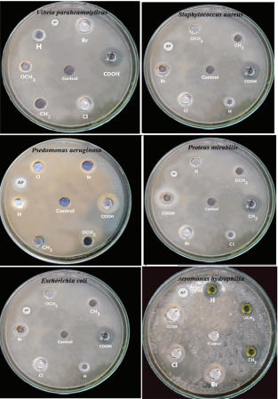

**Figure 3.1 Antibacterial activity of 4’-substituted 2-benzylidene-1,3-indandiones**

**3.2.2 Substituent effects on the antibacterial activity of the substituted 2-benzylidene-**

**1,3-indandione.**

In the present investigation the antibacterial activities of several microorganisms with substituted 2-benzylidene-1,3-indandiones has been correlated with SSP equation (), DSP equations () and Yukawa-Tsuno equation (). In order to express the effect of substituents quantitatively, it was considered to correlate the logarithm of inhibition zone radius (IZR) of all the organisms at the same concentration with the Hammett substituent constants.

**3.2.3 *Aeromonas hydrophila*.**

The antibacterial activity of *Aeromonas hydrophila* shows a range of 5-12 mm while that of the standard drug Amphotericin-B show a value of 21 mm given in table (3.1). The results of SSP equation are presented in table (3.2) and the correlation is satisfactory with *σp*constant (Eq. 3.1) and the Hammett plot Fig. (3.1) clearly, shows the positive sign of the slope reveals a normal substituent effect.

log IZR = 0.48 *σp* + 0.839 (3.1)

(±0.04) (±0.012)

r = 0.981, n = 6, F = 104.12

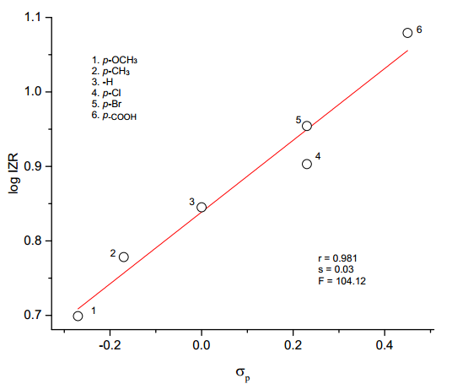

**Fig.3.1 Hammett plot of log IZR vs σp**

Multiple regressions have been performed for each of the resonance scales (*σ*R, *σ*R+, *σ*R-) and judicious choice of *σ*R- with the least standard error and excellent correlation coefficient (Table 3.3) and this leads to the values of *ρI* (=0.61) and *ρR*(=0.86) which also given in Eqs. (3.2) and (3.3).

log IZR = 0.61 *σ*I + 0.68 *σ*R + 0.86 (3.2)

(±0.05) (±0.06) (±0.02)

R = 0.991, SE = 0.02, n = 6, F = 84.98

log IZR = 0.41 F + 0.46 R + 0.84 (3.3)

(±0.08) (±0.08) (±0.02)

R = 0.979, SE = 0.03, n = 5, F = 22.27

The sign of *ρI*  and *ρR* are positive reveals that the normal substituent effect operates, i.e., an electron withdrawing substituents show the higher value of inhibition zone radii while that of electron releasing substituents show a lower value of zone radii. The magnitude of *ρR* is greater than the *ρI* indicate the predominance of resonance effect over inductive effectx.

**Table 3.2: Results of statistical treatment of log IZR (mm) with σp**, **σpo**, **σp+**, **σp+/ σp**,

**σp+/ σp-, σp+/ σp / σp-**, **substituent constants using single parameter equation ().**

|  |  |  |  |  |  |  |  |  |
| --- | --- | --- | --- | --- | --- | --- | --- | --- |
|  |  |  |  |  |  |  |  |  |
| **S.No.** | **Bacteria** | **Scale** | ***ρ*** | **r** | **s** | **F** | **log(IZR)o** | **n** |
|  |  |  |  |  |  |  |  |  |
| 1 | ***Aeromonas***  ***hydrophila*** | ***σp*** | 0.48±0.04 | 0.981 | 0.03 | 104.12 | 0.839±0.012 | 6 |
|
|  |  | ***σpo*** | 0.50±0.11 | 0.915 | 0.06 | 20.56 | 0.815±0.028 | 6 |
|  |  | ***σp+*** | 0.30±0.05 | 0.950 | 0.05 | 37.47 | 0.897±0.019 | 6 |
|  |  | ***σp+/ σp*** | 0.29±0.06 | 0.927 | 0.06 | 24.42 | 0.878±0.023 | 6 |
|  |  | ***σp+/ σp-*** | 0.26±0.03 | 0.981 | 0.03 | 102.65 | 0.879±0.012 | 6 |
|  |  | ***σp+/ σp / σp-*** | 0.25±0.03 | 0.972 | 0.04 | 67.47 | 0.865±0.015 | 6 |
| **2** | ***Escherichia coli*** | ***σp*** | 0.39±0.03 | 0.985 | 0.02 | 134.03 | 0.896±0.008 | 6 |
|
|  |  | ***σpo*** | 0.40±0.09 | 0.918 | 0.05 | 21.5 | 0.877±0.022 | 6 |
|  |  | ***σp+*** | 0.25±0.04 | 0.960 | 0.03 | 47.81 | 0.944±0.014 | 6 |
|  |  | ***σp+/ σp*** | 0.23±0.04 | 0.940 | 0.04 | 30.76 | 0.928±0.017 | 6 |
|  |  | ***σp+/ σp-*** | 0.20±0.02 | 0.975 | 0.03 | 78.24 | 0.929±0.011 | 6 |
|  |  | ***σp+/ σp / σp-*** | 0.20±0.03 | 0.970 | 0.03 | 64.73 | 0.917±0.012 | 6 |
| 3 | ***Pseudomonas aeruginosa*** | ***σp*** | 0.45±0.05 | 0.976 | 0.03 | 81.07 | 0.853±0.013 | 6 |
|  |  | ***σpo*** | 0.47±0.10 | 0.916 | 0.06 | 21.05 | 0.83±0.026 | 6 |
|  |  | ***σp+*** | 0.30±0.03 | 0.986 | 0.02 | 140.74 | 0.909±0.01 | 6 |
|  |  | ***σp+/ σp*** | 0.28±0.04 | 0.963 | 0.04 | 52.47 | 0.89±0.015 | 6 |
|  |  | ***σp+/ σp-*** | 0.24±0.03 | 0.968 | 0.04 | 61.35 | 0.891±0.014 | 6 |
|  |  | ***σp+/ σp / σp-*** | 0.24±0.03 | 0.965 | 0.04 | 54.32 | 0.877±0.015 | 6 |
|  |  |  |  |  |  |  |  |  |
| **4** | ***Proteus miratrilis*** | ***σp*** | 0.52±0.03 | 0.992 | 0.02 | 257.61 | 0.852±0.008 | 6 |
|  |  | ***σpo*** | 0.55±0.10 | 0.943 | 0.05 | 32.39 | 0.824±0.025 | 6 |
|  |  | ***σp+*** | 0.32±0.05 | 0.952 | 0.05 | 38.53 | 0.915±0.02 | 6 |
|  |  | ***σp+/ σp*** | 0.31±0.06 | 0.94 | 0.05 | 38.53 | 0.895±0.022 | 6 |
|  |  | ***σp+/ σp-*** | 0.27±0.04 | 0.953 | 0.05 | 30.39 | 0.895±0.02 | 6 |
|  |  | ***σp+/ σp / σp-*** | 0.27±0.04 | 0.956 | 0.05 | 40.009 | 0.88±0.019 | 6 |
| **5** | ***Vibrio paraheamolyticus*** | ***σp*** | 0.47±0.08 | 0.945 | 0.05 | 33.62 | 0.893±0.023 | 6 |
|  |  | ***σpo*** | 0.48±0.14 | 0.865 | 0.08 | 11.91 | 0.87±0.036 | 6 |
|  |  | ***σp+*** | 0.32±0.01 | 0.998 | 0.01 | 1337.04 | 0.952±0.003 | 6 |
|  |  | ***σp+/ σp*** | 0.31±0.02 | 0.990 | 0.02 | 200.93 | 0.932±0.009 | 6 |
|  |  | ***σp+/ σp-*** | 0.26±0.04 | 0.964 | 0.04 | 52.37 | 0.932±0.017 | 6 |
|  |  | ***σp+/ σp / σp-*** | 0.26±0.03 | 0.973 | 0.03 | 72.13 | 0.917±0.014 | 6 |
|  |  |  |  |  |  |  |  |  |
| **6** | ***Staphylococcus***  ***aureus*** | ***σp*** | 0.33±0.03 | 0.987 | 0.02 | 162.4 | 0.887±0.007 | 6 |
|  |  | ***σpo*** | 0.35±0.07 | 0.931 | 0.04 | 25.90 | 0.869±0.018 | 6 |
|  |  | ***σp+*** | 0.21±0.02 | 0.979 | 0.02 | 92.15 | 0.927±0.009 | 6 |
|  |  | ***σp+/ σp*** | 0.20±0.03 | 0.962 | 0.03 | 49.60 | 0.914±0.011 | 6 |
|  |  | ***σp+/ σp-*** | 0.18±0.14 | 0.988 | 0.16 | 164.59 | 0.914±0.006 | 6 |
|  |  | ***σp+/ σp / σp-*** | 0.26±0.03 | 0.973 | 0.03 | 72.13 | 0.917±0.014 | 6 |
|  |  |  |  |  |  |  |  |  |

**Table 3.3: DSP analysis of log IZR (mm) with dual parameter equations ( 2 ) and ( 3 )**

|  |  |  |  |  |  |  |  |  |  |  |
| --- | --- | --- | --- | --- | --- | --- | --- | --- | --- | --- |
| **S. No** | **Bacteria** | **Scale** | ***ρ*I** | ***ρ*R** | **R** | **SE** | **F** | **log(IZR)o** | **n** | **λ=*ρ*R/*ρ*I** |
|
| 1 | ***Aeromonas***  ***hydrophila*** | *σI, σR* | 0.44±0.17 | 0.50±0.17 | 0.890 | 0.08 | 05.72 | 0.87±0.05 | 6 | 1.14 |
|
|  |  | *σI ,σR+* | 0.08±0.18 | 0.17±0.06 | 0.876 | 0.08 | 04.97 | 0.92±0.07 | 6 | 2.12 |
|  |  | *σI ,σR-* | 0.61±0.05 | 0.68±0.06 | 0.991 | 0.02 | 84.98 | 0.86±0.02 | 6 | 1.11 |
|  |  | *F,R* | 0.41±0.08 | 0.46±0.08 | 0.979 | 0.03 | 22.27 | 0.84±0.02 | 5 | 1.12 |
|  |  |  |  |  |  |  |  |  |  |  |
| **2** | ***Escherichia coli*** | *σI ,σR* | 0.37±0.12 | 0.42±0.12 | 0.918 | 0.06 | 08.04 | 0.92±0.04 | 6 | 1.14 |
|  |  | *σI ,σR+* | 0.08±0.15 | 0.14±0.05 | 0.880 | 0.07 | 05.17 | 0.96±0.05 | 6 | 1.75 |
|  |  | *σI ,σR-* | 0.50±0.06 | 0.53±0.06 | 0.986 | 0.02 | 50.92 | 0.91±0.02 | 6 | 1.06 |
|  |  | *F,R* | 0.36±0.07 | 0.39±0.07 | 0.978 | 0.03 | 21.88 | 0.90±0.02 | 5 | 1.08 |
|  |  |  |  |  |  |  |  |  |  |  |
| **3** | ***Pseudomonas aeruginosa*** | *σI ,σR* | 0.43±0.10 | 0.53±0.11 | 0.956 | 0.05 | 16.19 | 0.89±0.03 | 6 | 1.23 |
|  |  | *σI ,σR+* | 0.06±0.14 | 0.17±0.05 | 0.920 | 0.06 | 08.35 | 0.94±0.05 | 6 | 2.83 |
|  |  | *σI ,σR-* | 0.56±0.10 | 0.62±0.11 | 0.966 | 0.04 | 20.96 | 0.87±0.03 | 6 | 1.11 |
|  |  | *F,R* | 0.43±0.22 | 0.56±0.23 | 0.999 | 0.009 | 341.28 | 0.88±0.007 | 5 | 1.30 |
|  |  |  |  |  |  |  |  |  |  |  |
| **4** | ***Proteus miratrilis*** | *σI ,σR* | 0.54±0.13 | 0.53±0.14 | 0.944 | 0.06 | 12.26 | 0.87±0.04 | 6 | 0.98 |
|  |  | *σI ,σR+* | 0.18±0.19 | 0.17±0.07 | 0.883 | 0.09 | 05.29 | 0.91±0.07 | 6 | 0.94 |
|  |  | *σI ,σR-* | 0.69±0.09 | 0.66±0.09 | 0.980 | 0.04 | 36.34 | 0.86±0.02 | 6 | 0.96 |
|  |  | *F,R* | 0.54±0.80 | 0.54±0.08 | 0.984 | 0.03 | 31.31 | 0.85±0.03 | 5 | 1.00 |
| **5** | ***Vibrio paraheamolyticus*** | σI ,σR | 0.42±0.08 | 0.61±0.08 | 0.98 | 0.03 | 36.82 | 0.95±0.02 | 6 | 1.45 |
|  |  | σI ,σR+ | 0.02±0.19 | 0.18±0.07 | 0.865 | 0.09 | 4.45 | 0.99±0.07 | 6 | 9.00 |
|  |  | σI ,σR- | 0.55±0.15 | 0.68±0.16 | 0.934 | 0.06 | 10.3 | 0.93±0.05 | 6 | 1.24 |
|  |  | F,R | 0.42±0.03 | 0.66±0.03 | 0.998 | 0.01 | 314.17 | 0.95±0.008 | 5 | 1.57 |
|  |  |  |  |  |  |  |  |  |  |  |
| 6 | ***Staphylococcus aureus*** | *σI,σR* | 0.31±0.09 | 0.37±0.10 | 0.931 | 0.04 | 9.72 | 0.91±0.03 | 6 | 1.19 |
|  |  | *σI ,σR+* | 0.05±0.12 | 0.12±0.04 | 0.889 | 0.05 | 5.65 | 0.95±0.04 | 6 | 2.40 |
|  |  | *σI ,σR-* | 0.41±0.05 | 0.47±0.05 | 0.985 | 0.02 | 47.3 | 0.90±0.01 | 6 | 1.15 |
|  |  | *F,R* | 0.29±0.19 | 0.36±0.19 | 0.998 | 0.007 | 216.31 | 0.90±0.006 | 5 | 1.24 |

The result of Yukawa-Tsuno equation (3.4), is given in table (3.4) also indicate that the magnitude of ‘r’ is very low (<1) proved less contribution of resonance effect.

log IZR = 0.45 σp + 0.07 (σp+- σp) + 0.85 (3.4)

(±0.07) (±0.01) (±0.02)

R = 0.984, SE = 0.03, n = 6, F = 45.17

**Table 3.4: Results of multiple regression analysis of log IZR (mm) with σp, (σp+- σp) and**

**σpo, (σp+- σpo) constants using Yukawa – Tsuno equation (4).**

|  |  |  |  |  |  |  |  |  |
| --- | --- | --- | --- | --- | --- | --- | --- | --- |
|  |  |  |  |  |  |  |  |  |
| **S.No.** | **Bacteria** | **Scale** | ***ρ*** | **r** | **R** | **SE** | **F** | **n** |
|  |  |  |  |  |  |  |  |  |
|  |  |  |  |  |  |  |  |  |
| **1** | ***Aeromonas hydrophila*** | σp,( σp+- σp) | 0.45±0.07 | 0.07±0.01 | 0.984 | 0.03 | 45.17 | 6 |
|  |  | σpo,( σp+- σpo) | 0.41±0.09 | 0.20±0.90 | 0.970 | 0.04 | 23.99 | 6 |
|  |  |  |  |  |  |  |  |  |
| **2** | ***Escherichia coli*** | σp,( σp+- σp) | 0.35±0.04 | 0.07±0.04 | 0.992 | 0.02 | 94.85 | 6 |
|  |  | σpo,( σp+-  σpo) | 0.33±0.06 | 0.17±0.06 | 0.978 | 0.03 | 32.96 | 6 |
|  |  |  |  |  |  |  |  |  |
| **3** | ***Pseudomonas aeruginosa*** | σp,( σp+- σp) | 0.38±0.04 | 0.12±0.05 | 0.993 | 0.02 | 110.24 | 6 |
|  |  | σpo,( σp+-  σpo) | 0.37±0.03 | 0.23±0.03 | 0.996 | 0.02 | 173.63 | 6 |
| **4** | ***Proteus miratrilis*** | σp,( σp+- σp) | 0.50±0.04 | 0.04±0.04 | 0.994 | 0.02 | 122.79 | 6 |
|  |  | σpo,( σp+-  σpo) | 0.46±0.07 | 0.18±0.07 | 0.983 | 0.03 | 44.05 | 6 |
|  |  |  |  |  |  |  |  |  |
|  |  |  |  |  |  |  |  |  |
| **5** | ***Vibrio paraheamolyticus*** | σp,( σp+- σp) | 0.34±0.04 | 0.22±0.05 | 0.993 | 0.02 | 115.03 | 6 |
|  |  | σpo,( σp+-  σpo) | 0.33±0.02 | 0.31±0.02 | 0.998 | 0.009 | 556.9 | 6 |
|  |  |  |  |  |  |  |  |  |
| **6** | ***Staphylococcus aureus*** | σp,( σp+- σp) | 0.29±0.02 | 0.07±0.02 | 0.998 | 0.008 | 311.31 | 6 |
|  |  | σpo,( σp+-  σpo) | 0.28±0.02 | 0.15±0.02 | 0.995 | 0.01 | 145.43 | 6 |
|  |  |  |  |  |  |  |  |  |

**3.2.4 *Escherichia coli***

The antibacterial activity of *Escherichia coli* shows a range of 6 to12 mm and that of the standard Amphotericin-B show a value of 16 mm given in table 3.1. The results of SSP equations are tabulated in table 3.2 and the correlation is good with σp constants given in Eq.3.5. The positive sign of the slope, reveals a normal substituent effect. The Hammett plot of log IZR vs σp is shown in Fig. (3.2).

log IZR = 0.39 σp + 0.896 (3.5)

(±0.03) (±0.008)

r = 0.985, s = 0.02, n = 6, F = 134.03

The DSP analysis in Table 3.3, afford good correlations are shown in Eqs. (3.6) and (3.7).

log IZR = 0.50 σI  + 0.53 σR  + 0.92 (3.6)

(±0.06) (±0.06) (±0.02)

R = 0.986, SE = 0.02, n = 6, F = 50.92

log IZR = 0.36 F + 0.39 R + 0.90 (3.7)

(±0.07) (±0.07) (±0.02)

R = 0.978, SE = 0.03, n = 5, F = 21.88

The Yukawa-Tsuno equation (3.8) in the table (3.4) also indicates that the magnitude of ‘r’ is less than 1 with excellent correlation.

log IZR = 0.35 σp + 0.07 (σp+- σp) + 0.91 (3.8)

(±0.04) (±0.04) (±0.01)

R = 0.992, SE = 0.02, n = 6, F = 94.85

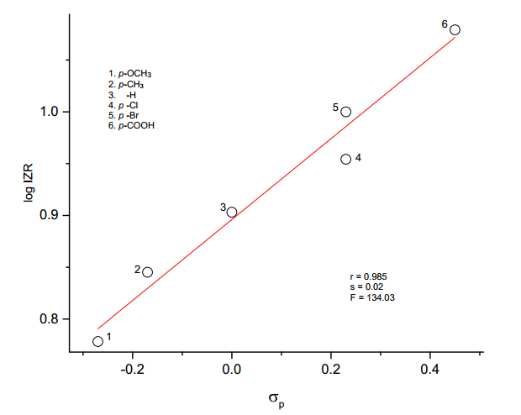

**Fig.3.2 Hammett plot of log IZR vs σp**

**3.2.5 *Pseudomonas aeruginosa***

The antibacterial activity of *Pseudomonas aeruginosa* shows a range of 5 to 11 mm while that of the standard Amphotericin-B show a value of 21 mm. The results of SSP equations are calculated and tabulated in the table (3.2) and a satisfactory correlation was given by σp+ Hammett constant in Eq. (3.9) and the Hammett plot Fig. (3.3) clearly, shows that the positive sign of the slope reveals a normal substituent effect.

log IZR = 0.30 *σp+* + 0.909 (3.9)

(±0.03) (±0.01)

r = 0.986, s = 0.02, n = 6, F = 140.74

The best fit of DSP analysis is given by σR- scale and is shown in Eqs. (3.10) and (3.11).

log IZR = 0.56 σI  + 0.62 σR- + 0.87 (3.10)

(±0.10) (±0.11) (±0.03)

R = 0.966, SE = 0.04, n = 6, F = 20.96

log IZR = 0.43 F + 0.56 R + 0.88 (3.11)

(±0.22) (±0.23) (±0.007)

R = 0.999, SE = 0.009, n = 5, F = 341.28

The Yukawa-Tsuno equation (3.12) and table (3.4) proved the less contribution of resonance effect with good correlation.

log IZR = 0.37 σpo + 0.23 (σp+- σpo) + 0.87 (3.12)

(±0.03) (±0.03) (±0.01)

R = 0.996, SE = 0.02, n = 6, F = 173.63

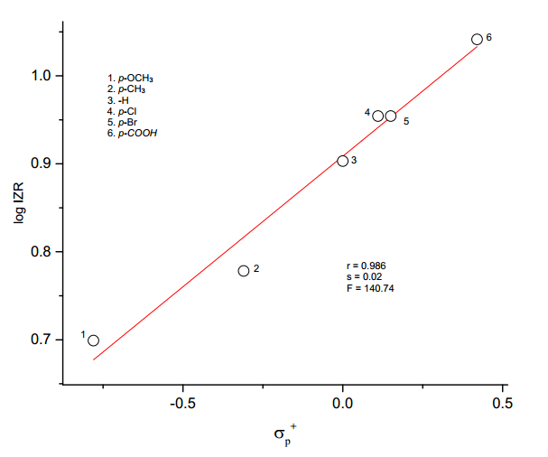

**Fig.3.3 Hammett plot of log IZR vs σp+**

**3.2.6 *Proteus miratrilis***

This bacterium shows antibacterial activity zone of inhibition in the range of 5 to 12 mm and the standard Amphotericin-B shows a value of 18 mm as the zone of inhibition (Table 3.1). The results of SSP equations are presented in the table (3.2) and the correlation is excellent with σp Hammett constant given in Eq. 3.11. The positive sign of the slope, interprets normal substituent effects. The Hammett plot of log IZR vs σp is shown in the Fig. (3.4).

log IZR = 0.52 *σp* + 0.852 (3.11)

(±0.03) (±0.008)

r = 0.992, s = 0.02, n = 6, F = 257.61

DSP analysis has been performed for each of the resonance scale (*σR, σR+, σR-*). The best fit of DSP analysis for this bacterium is taken from satisfactory correlation coefficient (R) and least standard error (SE) of the regression equations (3.12) and (3.13) are given in Table 3.3.

log IZR = 0.69 *σI* + 0.66 *σR*  + 0.86 (3.12)

(±0.09) (±0.09) (±0.02)

R = 0.980, SE= 0.04, n = 6, F = 36.34

log IZR = 0.54 *F* + 0.54 *R* + 0.85 (3.13)

(±0.80) (±0.08) (±0.03)

R = 0.984, SE= 0.03, n = 5, F = 31.31

The Yukawa-Tsuno equation (3.14) and Table (3.4) shows that the value of ‘r’ is low (<1) shows less contribution of resonance effect.

log IZR = 0.50 σp  + 0.04 (σp+ - σp) + 0.86 (3.14)

(±0.04) (±0.04) (±0.01)

R = 0.994, SE = 0.02, n = 6, F = 122.79

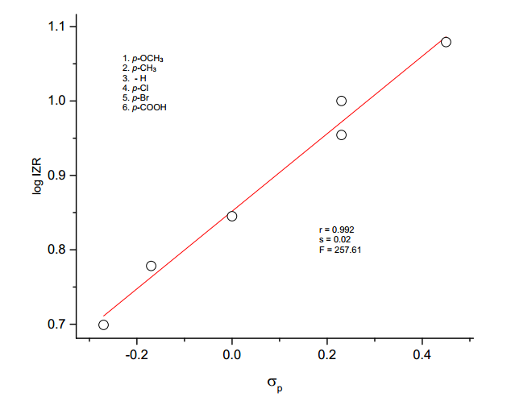

**Fig. 3.4 Hammett plot of log IZR vs σp**

**3.2.7 *Staphylococcus aureus***

The antibacterial activity of *Staphylococcus aureus* shows a range of 6 mm to 11 mm and the standard Amphotericin-B shows 16 mm as the zone of inhibition radius (Table 3.1). The results of SSP equations are presented in the table (3.2) and this gives a satisfactory correlation with Hammett constant σp+/σp- in equation (3.15) shown in Fig. (3.5). The plot shows normal substituent effects.

log IZR = 0.18 σp+/σp- + 0.914 (3.15)

(±0.14) (±0.006)

r = 0.988, s = 0.16, n = 6, F = 164.59

The DSP analysis in (Table 3.3), afford satisfactory correlations are shown in Eqs. (3.16) and (3.17).

log IZR = 0.41 *σI* + 0.47 *σR-* + 0.90 (3.16)

(±0.05) (±0.05) (±0.01)

R = 0.985, SE= 0.02, n = 6, F = 47.30

log IZR = 0.29 *F* + 0.36 *R* + 0.90 (3.17)

(±0.19) (±0.19) (±0.006)

R = 0.998, SE= 0.007, n = 5, F = 216.31

The sign of *ρ*I and *ρ*R are positive reveals that the electron releasing substituents decrease the inhibition zone radius and electron withdrawing substituents increase the zone radius.

The Yukawa-Tsuno equation (3.18) and Table (3.4) proved the less contribution of resonance effect.

log IZR = 0.29 σp  + 0.07 (σp+ - σp) + 0.90 (3.18)

(±0.02) (±0.02) (±0.06)

R = 0.998, SE = 0.008, n = 6, F = 311.31

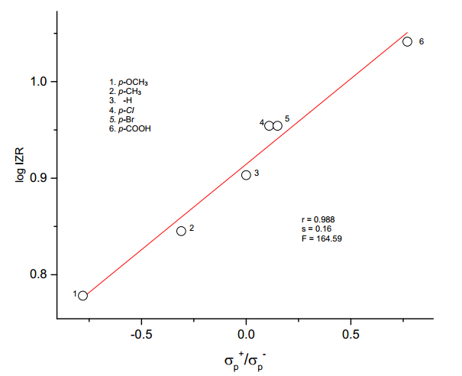

**Fig.3.5 Hammett plot of log IZR vs σp+/ σp-**

**3.2.8 *Vibrio paraheamolyticus***

This bacterium *Vibrio paraheamolyticus* shows inhibition zone radius in the range of 5 mm to 12 mm and the standard Amphotericin-B shows a radius of 18 mm. The SSP analysis for this bacterium shows excellent correlation with σp+ Hammett constant and is given in equation (3.19) and is shown in Fig. (3.6).

log IZR = 0.32 σp+  0.952 (3.19)

(±0.01) (±0.003)

r = 0.998, s = 0.01, n = 6, F = 1337.04

DSP analysis has been performed for each of the resonance scale (*σR, σR+, σR-*). The best fit for this is taken from satisfactory correlation with σ*R* shown in equations (3.20) and (3.21) which is given in table 3.3.

log IZR = 0.42 *σI* + 0.61 *σR*  + 0.95 (3.20)

(±0.08) (±0.08) (±0.02)

R = 0.980, SE= 0.03, n = 6, F = 36.82

log IZR = 0.42 *F* + 0.66 *R* + 0.95 (3.21)

(±0.03) (±0.03) (±0.008)

R = 0.998, SE= 0.01, n = 5, F = 314.17

The Yukawa-Tsuno equation (3.22) and Table (3.4) shows that the value of ‘r’ is low (<1) shows less contribution of resonance effect.

log IZR = 0.34 σp  + 0.22 (σp+ - σp) + 0.95 (3.22)

(±0.04) (±0.05) (±0.01)

R = 0.993, SE = 0.02, n = 6, F = 115.0

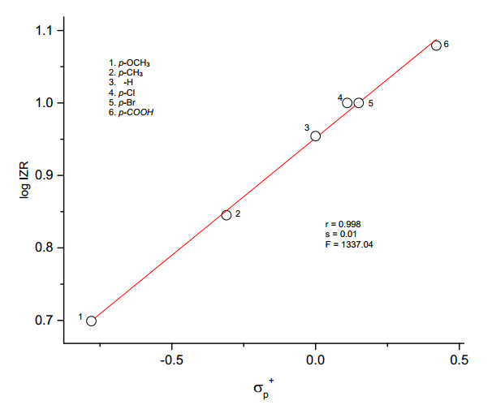

**Fig. 3.6 Hammett plot of log IZR vs σp+**

**3.3 Antibacterial activity of substituted 5-benzylidenebarbituric acid: A structure-reactivity**

**study.**

**3.3.1 Results and discussion**

In this study, gram-positive bacteria (*Staphylococcus aureus*) and five gram-negative bacteria (*Escherichia coli, Klebsiella oxytoca, Proteus mirabilis, Pseudomonas aeruginosa and Shigella sonnei)* were used. The result of the present study showed a broad range of antibacterial activity, shown in Figure 3.7. The average inhibition zone diameter for the various bacteria are shown in Table 3.5. The order of antibacterial activity of compounds (1 to 7) for all the microorganism were in the following sequence.

-OCH3<-OH < -CH3< -H < -Cl < -Br< -NO2

**Table 3.5**. **Antibacterial activity (zone of inhibition(mm) values) of substituted**

**5-benzylidenebarbituric acid**

|  |  |  |  |  |  |  |  |  |  |
| --- | --- | --- | --- | --- | --- | --- | --- | --- | --- |
| **S.No.** | **Name of the microorganism** | **Inhibition zone diameter** | | | | | | | |
| **Standard (Amphotericin-B)** | **-OCH3** | **-OH** | **-CH3** | **-H** | **-Cl** | **-Br** | **-NO2** |
|  |  |  |  |  |  |  |  |  |  |
| **1** | ***Escherichia coli*** | **21** | **9** | **10** | **12** | **14** | **16** | **17** | **20** |
|  |  |  |  |  |  |  |  |  |  |
| **2** | ***Klebsiella oxytoca*** | **16** | **8** | **12** | **14** | **16** | **20** | **21** | **28** |
|  |  |  |  |  |  |  |  |  |  |
| **3** | ***Proteus mirabilis*** | **18** | **7** | **9** | **10** | **11** | **16** | **19** | **22** |
|  |  |  |  |  |  |  |  |  |  |
| **4** | ***Pseudomonas aeruginosa*** | **21** | **11** | **13** | **15** | **16** | **20** | **23** | **28** |
|  |  |  |  |  |  |  |  |  |  |
| **5** | ***Shigella Sonnei*** | **16** | **8** | **10** | **11** | **12** | **14** | **18** | **21** |
|  |  |  |  |  |  |  |  |  |  |
| **6** | ***Staphylococcus aureus*** | **18** | **7** | **12** | **13** | **14** | **16** | **23** | **28** |
|  |  |  |  |  |  |  |  |  |  |

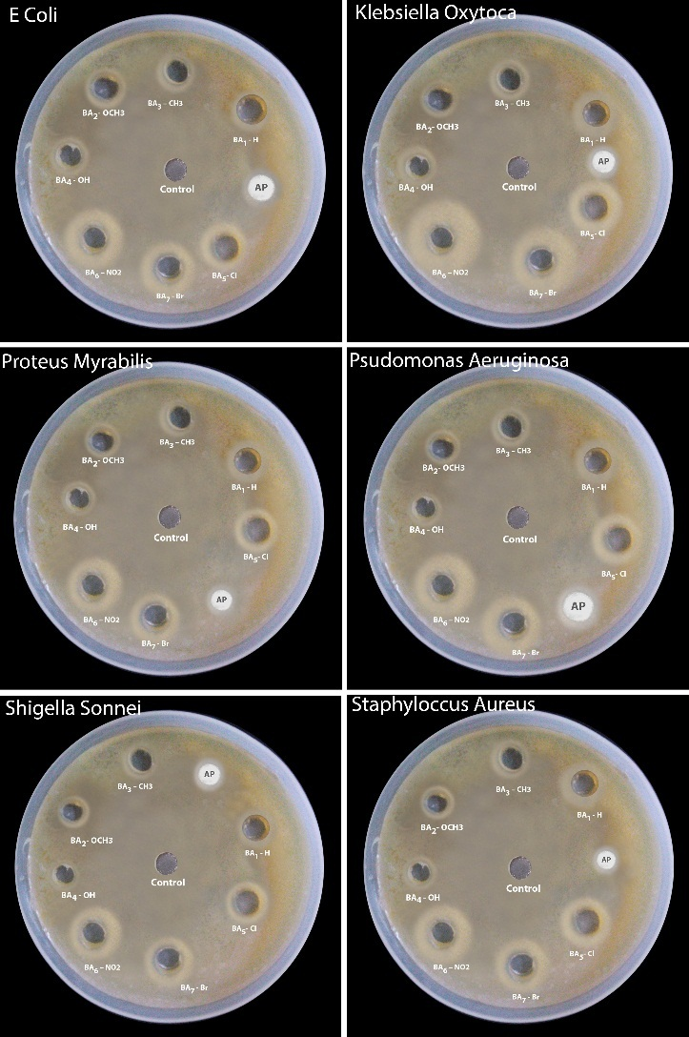

**Figure 3.7 Antibacterial activity of substituted 5-benzylidenebarbituric acids**

If atom or group attracts electrons less strongly than hydrogen, it is said to have +I effect (electron repelling or electron releasing) viz., -OCH3, -OH, -CH3 groups showing lesser zone inhibition values compared to unsubstituted phenyl ring (-H).

**3.3.2 Substituent effects on the antibacterial activity of substituted 5-benzylidenebarbituric**

**acids.**

In order to express the effect of substituents quantitatively, it was considered worthwhile to correlate the logarithm of inhibition zone diameter (IZD) of (1 to 7) at the same concentration with the Hammett substituent constants for all the microorganisms.

**3.3.3** ***Escherichia coli***

This bacterium ***Escherichia coli*** shows antibacterial activity in the range between 9 to 20 mm as the zone inhibition diameter. The standard Amphotericin-B shows 21 mm zone inhibition diameter. The SSP analysis for this is tabulated in table 3.6 and is given in equation 3.23 in which the positive value of the reaction constant (*ρ*) indicates that electron withdrawing substituents increase the antibacterial activity and the electron releasing substituents retard it.

log IZD = 0.25 *σp*+ / *σp* + 1.135 (3.23)

(±0.02) (±0.01)

r = 0.977, s= 0.03, n = 7, F = 104.92